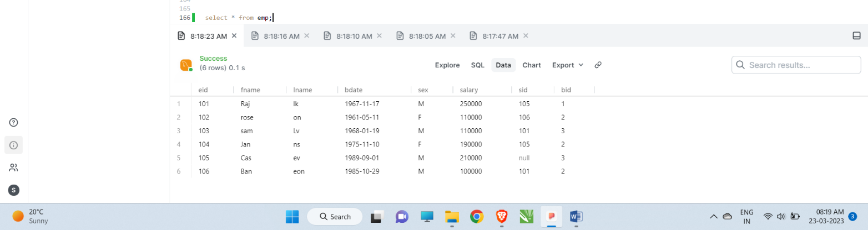

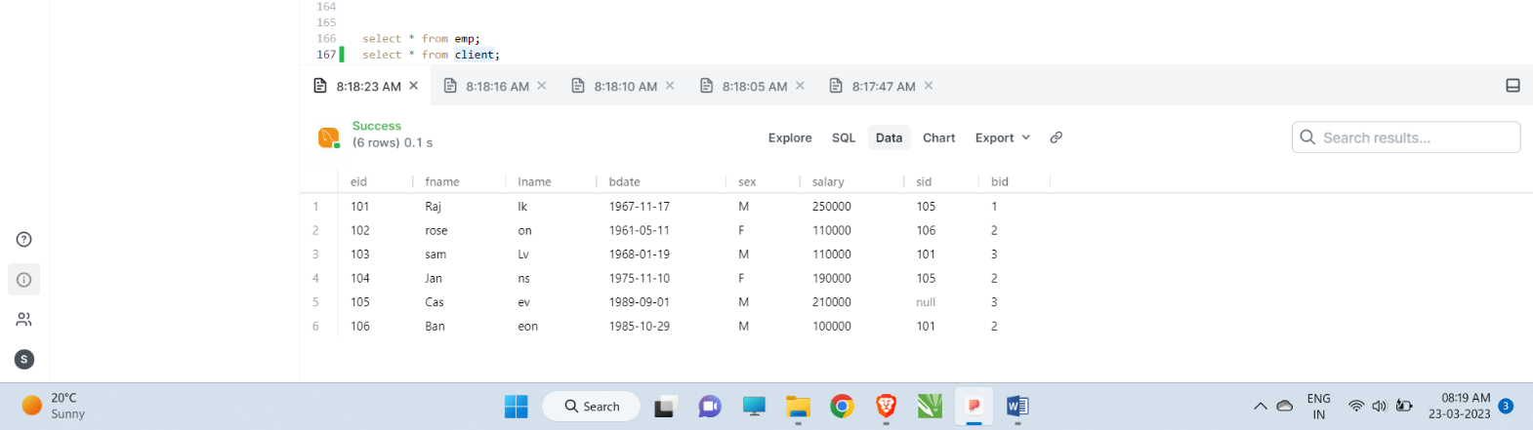

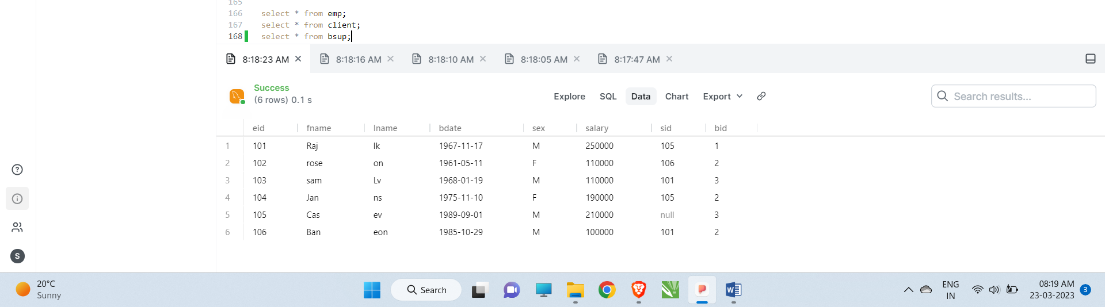

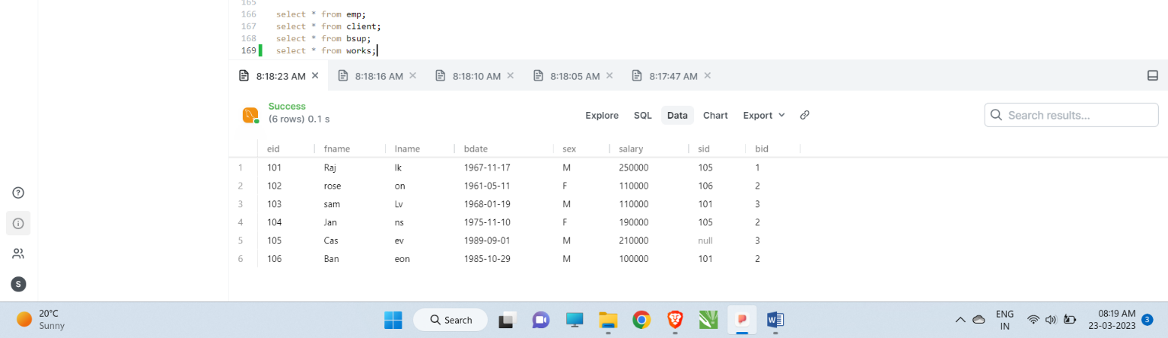

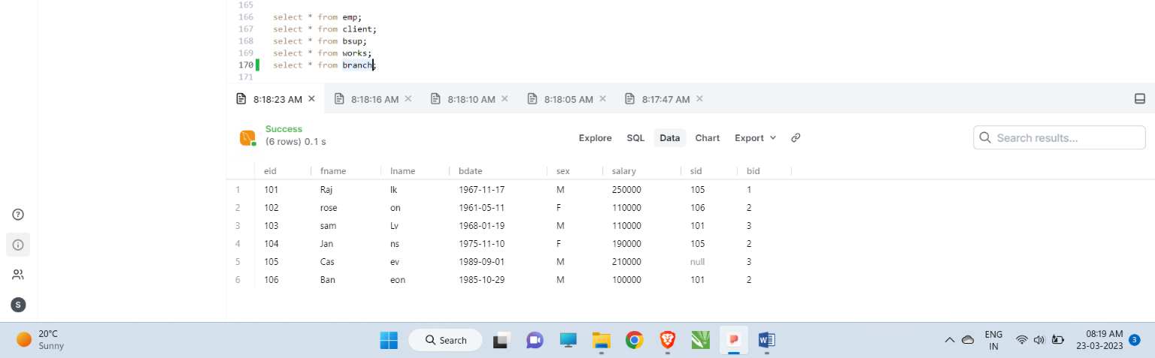

**Creating Tables**

create table emp(

    eid int primary key,

    fnmae varchar(20),

    lname varchar(20),

    bdate DATE,

    sex varchar(5),

    salary int,

    sid int,

    bid int

);

create table branch(

    bid int primary key,

    bname varchar(20),

    mgid int,

    mgsdate date,

    foreign key(mgid) references emp(eid) on delete set NULL

);

alter table emp

add foreign key(bid)

references branch(bid)

on delete set NULL;

alter table emp

add foreign key(sid)

references emp(eid)

on delete set NULL;

create table client(

    cid int primary key,

    cname varchar(20),

    bid int,

    foreign key(bid) references branch(bid) on delete set NULL

);

create table works(

    eid int,

    cid int,

    totals int,

    primary key(eid, cid),

    foreign key(eid) references emp(eid) on delete cascade,

    foreign key(cid) references client(cid) on delete cascade

);

create table bsup(

    bid int,

    sname varchar(20),

    stype varchar(20),

    primary key(bid, sname),

    foreign key(bid) references branch(bid) on delete cascade

);

**Inserting Values**

INSERT INTO emp VALUES(101, 'Raj', 'lk', '1967-11-17', 'M', 250000, NULL, NULL);

INSERT INTO emp VALUES(102, 'rose', 'on', '1961-05-11', 'F', 110000, 101, 1);

INSERT INTO emp VALUES(103, 'sam', 'Lv', '1968-01-19', 'M', 110000, NULL, NULL);

INSERT INTO emp VALUES(104, 'Jan', 'ns', '1975-11-10', 'F', 190000, NULL, NULL);

INSERT INTO emp VALUES(105, 'Cas', 'ev', '1989-09-01', 'M', 210000, NULL, NULL);

INSERT INTO emp VALUES(106, 'Ban', 'eon', '1985-10-29', 'M', 100000, NULL, NULL);

INSERT INTO branch VALUES(1, 'Corporate', 101, '2006-02-09');

INSERT INTO branch VALUES(2, 'ford', 103, '2009-09-09');

INSERT INTO branch VALUES(3, 'keep', 104, '2004-12-11');

--Updating Emp Table

UPDATE emp

SET bid = 1

WHERE eid = 101;

update emp

set sid=106

where eid=102;

update emp

set sid=101

where eid=106;

update emp

set sid=105

where eid=101;

update emp

set sid=106

where eid=102;

update emp

set sid=105

where eid=104;

update emp

set sid=101

where eid=103;

insert into bsup values(2, 'School', 'Book');

insert into bsup values(1, 'station', 'pen');

insert into bsup values(3, 'foundation', 'cutter');

insert into bsup values(3, 'class', 'pen');

insert into bsup values(1, 'class', 'Book');

insert into client values(201, 'mill', 3);

insert into client values(202, 'rock', 1);

insert into client values(203, 'pick', 2);

insert into client values(204, 'jam', 2);

insert into c+lient values(205, 'rick', 3);

insert into works values(105, 205, 5500000);

insert into works values(101, 201, 5500000);

insert into works values(106, 204, 5500000);

insert into works values(104, 203, 5500000);

insert into works values(102, 204, 5500000);

*-- Find all employees ordered by salary*

select *

from emp

order by salary desc;

*-- Find all employees ordered by sex then name*

select *

 from emp

 order by sex, fname, lname;

*-- Find the first 5 employees in the table*

select *

from emp

limit 5;

*-- Find the first and last names of all employees*

select fname,lname

from emp;

*-- Find all female employee*

select COUNT(eid)

from emp

where sex='F';

*-- Find the sum of all employee's salaries*

select SUM(salary)

from emp;

*-- Count the sale’s*

select SUM(totals),cid

from works

group by cid;

*-- Find all employees born in September*

select *

from emp

where bdate LIKE '____-09%';

*-- Find any clients who are mill*

select *

from client

where cname='mill';

*-- Find a list of employee and branch names*

select fname

from emp

UNION

select bname

from branch;

*-- Find a list of all clients & branch suppliers' names*

select cname

from client

union

select sname

from bsup;

*-- JOIN table*

select emp.eid, emp.fname, branch.bname

from emp

join branch

on emp.eid = branch.mgid;

select emp.eid, emp.fname, branch.bname

from emp

left join branch

on emp.eid = branch.mgid;